Contents
Introduction 1
What is Token based Authentication? 2
How Token Based Authentication works? 2
Install the required OWIN component using Nuget Packages 3
Advantages and Disadvantages 3
Advantages: 3
Disadvantage 3

Introduction

The Open Web Interface for .NET (OWIN) defines a standard interface between .NET web servers and web applications. It provides the implementation of the OWIN specification. The OAuth authorization framework enables a third-party application to obtain limited access to a HTTP service.
ASP.NET Web API is a service which can be accessed over the HTTP by any client. So, providing security to the Web API is very important, which can be easily done with the process called Token based authentication. Token-based authentication is a process where the user sends his credential to the server, server will validate the user details and generate a token which is sent as response to the users, and user store the token in client side, so client do further HTTP call using this token which can be added to the header and server validates the token and send a response. This article will give you a step by step process to implement the token-based authentication in ASP.NET Web API 2.
Currently the preferred approach to authenticate the users is to use a signed token and this token is sent to the server with each request. The following are the benefits for using this approach.
- Scalability of Servers
the token itself contains all the information of the user that is needed for authentication, so Web Farm extension is an easy task. There is no dependence on shared session stores.

- Loosely Coupling
Our front-end application is not coupled with a specific authentication mechanism. The token is generated from the server and our web API has a built-in way to understand this token and perform authentication.

- Mobile Friendly
This type of authentication does not require cookies, so this authentication type can be used with mobile applications.

What is Token based Authentication?
- Web API is a service which can be accessed over the HTTP by any client. So, providing security to the Web API is very important, which can be easily done with the process called Token based authentication.
- Token authentication is a form of “two-factor authentication”, meaning users must supply two unique factors when logging in. The first factor is something the user knows, like a password or PIN. The second factor is provided by an Authenticator, a hardware or software “token” with a code that changes randomly.

How Token Based Authentication works?

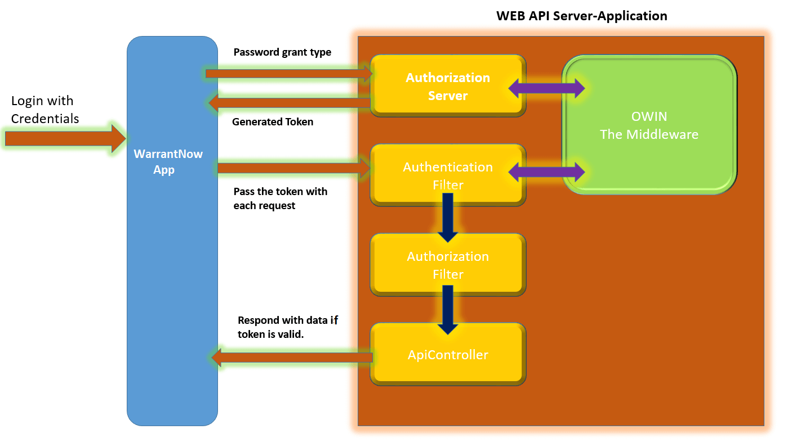
Fig: Control Flow of Token based Authentication
- A token is a piece of data which is created by server, and contains enough data to identify a particular user and it has expiry time. The client application first sends a request to Authentication server with valid credentials. Authentication server sends an Access token to the client as a response. The client application then uses the token to access the restricted resources in next requests, till the token is valid. If the Access token is expired, then client application can request for new access token by using Refresh token.

Install the required OWIN component using Nuget Packages

In this step, we need to install Nuget packages that are required to set up our OWIN server and configure the Web API to be hosted within the OWIN server. The "Microsoft.AspNet.Identity.Owin" package provides many useful extensions and we will use this while working with ASP.Net Identity on top of OWIN. It also downloads some other dependency packages. One of those dependency packages is "Microsoft.Owin.Security.OAuth". This is a core package required to support any standard OAuth 2.0 authentication workflow. The “Microsoft.Owin.Host.SystemWeb” namespace contains the types related to handling OWIN requests. It helps us to run OWIN-based applications on IIS using the ASP.NET request pipeline.

Install-Package Microsoft.Owin.Host.SystemWeb -Version 2.1.0
Install-Package Microsoft.AspNet.Identity.Owin -Version 2.0.1
Install-Package Microsoft.AspNet.Identity.EntityFramework -Version 2.0.1
Install-Package Microsoft.Owin.Security.OAuth -Version 2.1.0
Install-Package Microsoft.Owin.Cors -Version 2.1.0

Advantages and Disadvantages
It is very simple, right? Now you have an initial overview of Token Based Authentication which is one of the security solutions of WebAPI. Let’s continue to summarize its advantages and disadvantages compared with cookie based Authentication.

Advantages:
Scalable: Usually the token itself holds all encrypted user info, so adding more servers to your web farm is an easy task.
Mobile Friendly: Comparing with cookies, storing token in native mobile platforms or browsers could be a standard way.
Decoupled: Any server providing token Auth service could be an alternative option.
Safer: CSRF Attack Prevent.
Performance: Decoding token to get use info is usually faster than querying DB.
Disadvantage: Need additional code to store and send token.

